

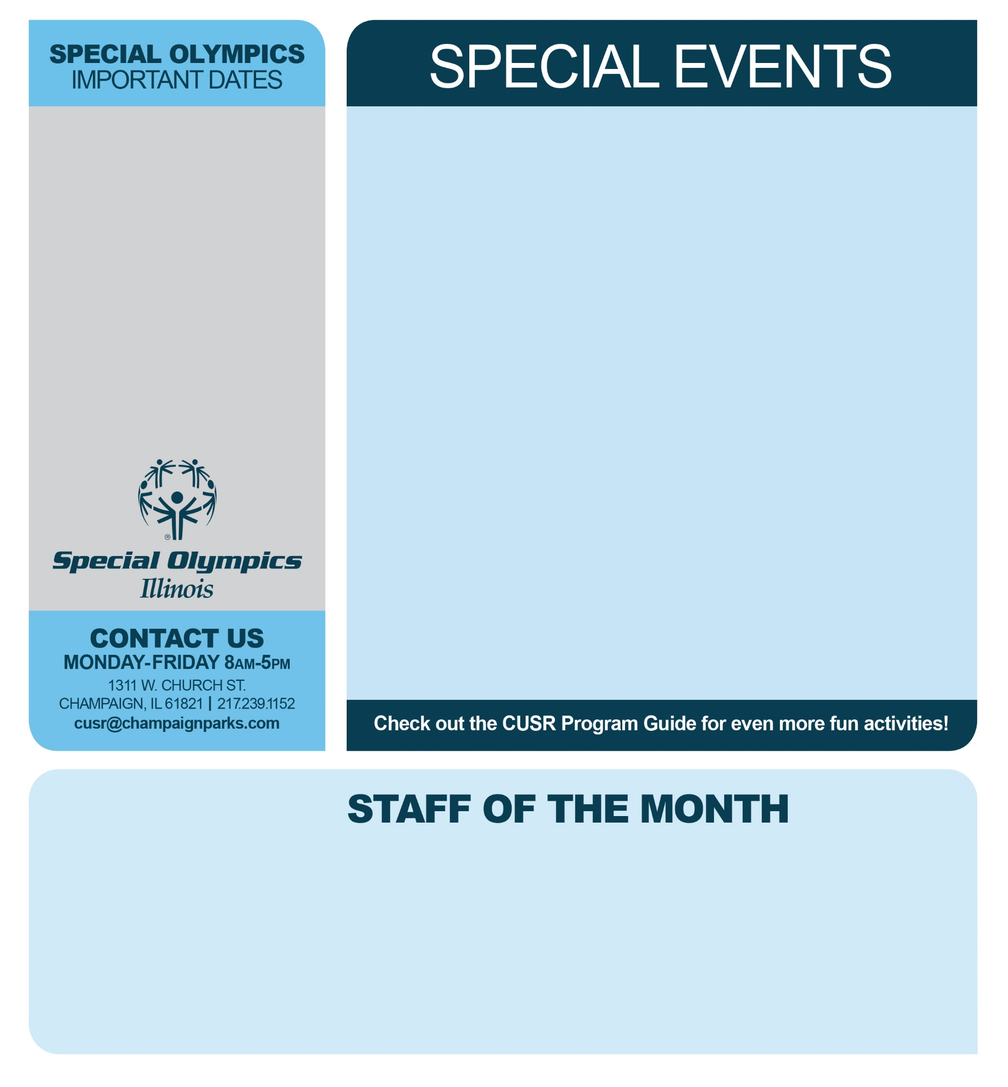

**Elf, The Musical: 16+ Pizza & Movie: 16+**

*Paramount Theatre Hays Rec Center*

Sunday, January 7th Wednesday, January 31st

9:30am-6:30pm 6:00-8:30pm

**Market Place Mall Scavenger Hunt: 16+**

*Market Place Mall*

Tuesday, January 9th

5:30pm-7:00pm

**Wine Glasses & Mocktails: 21+ Tie-Dye Party: 16+**

*Hays Rec Center Hays Rec Center*

Thursday, January 11th Tuesday, January 16th

6:00-7:00pm 6:00-7:30pm

**PBR: Professional Bull Riding: 21+**

*Rosemont, Illinois*

Saturday, January 13th

3:00pm-11:30pm

**Chicago Bulls Basketball: 18+ Discover the Eagles: 18+**

*Chicago, Illinois Starved Rock*

Sunday, January 28th Wednesday, January 24th

11:30am-6:30pm 9:00am-4:30pm

**January 14th**

*Men’s District Basketball Bloomington*

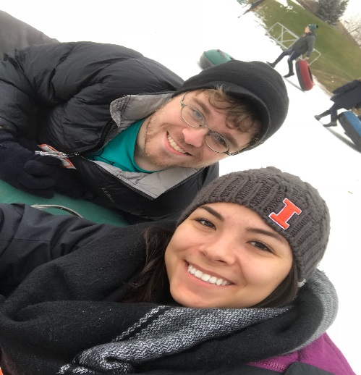

**CORINA BOTTCHER**

Hi! My name is Corina Bottcher. I am a current student at the University of Illinois studying human development and family studies with a concentration in child development. I started working with Champaign-Urbana Special Recreation in May 2016 as an Inclusion Aide. I now work with the adult participants doing various activities. I love working at CUSR because I get to spend my time with the population I see myself working with in my future career as a Developmental Therapist.

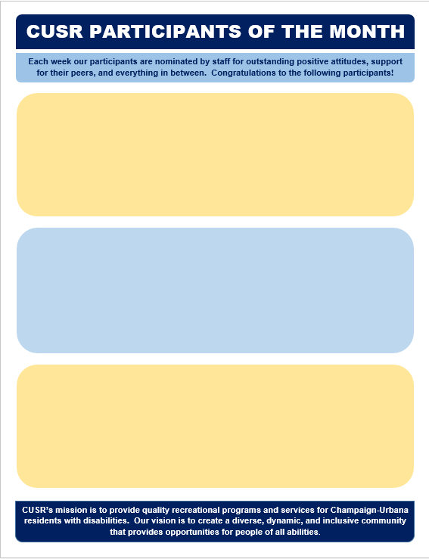

JACOB WILKEY: NOV 20TH-24TH

Jacob has been actively participating in CUSR programs since 2015. He is friendly, witty, and so much fun to be around. Congratulations, Jacob!

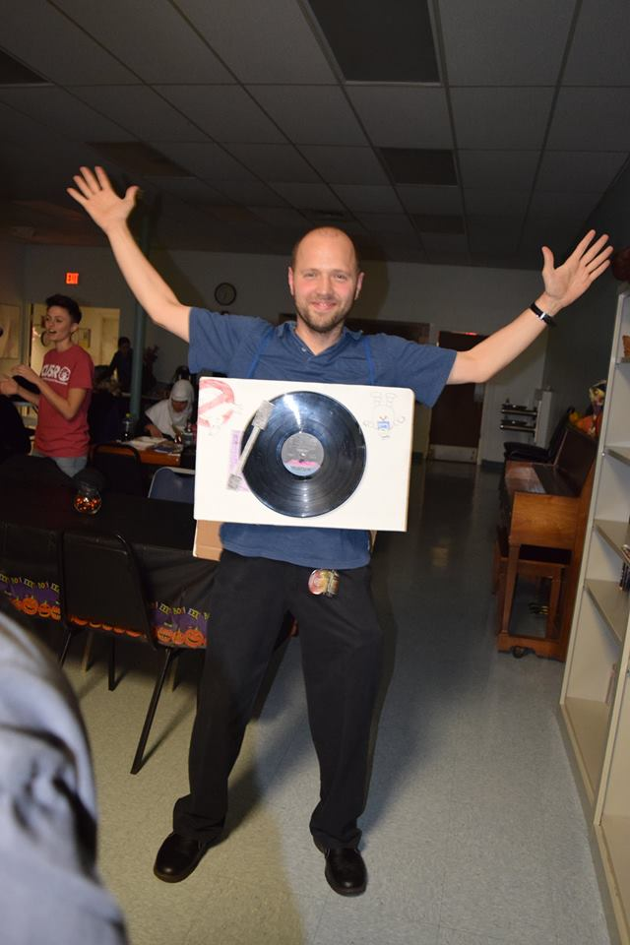

SOPHIA GANT: DEC 11-15TH

Sophia has been with CUSR since summer of 2016 and has brought tons of smiles to both our FKO Summer Camp and After School Program. Sophia is a boall of energy that makes everyone around her happy. Congratulations, Sophia!

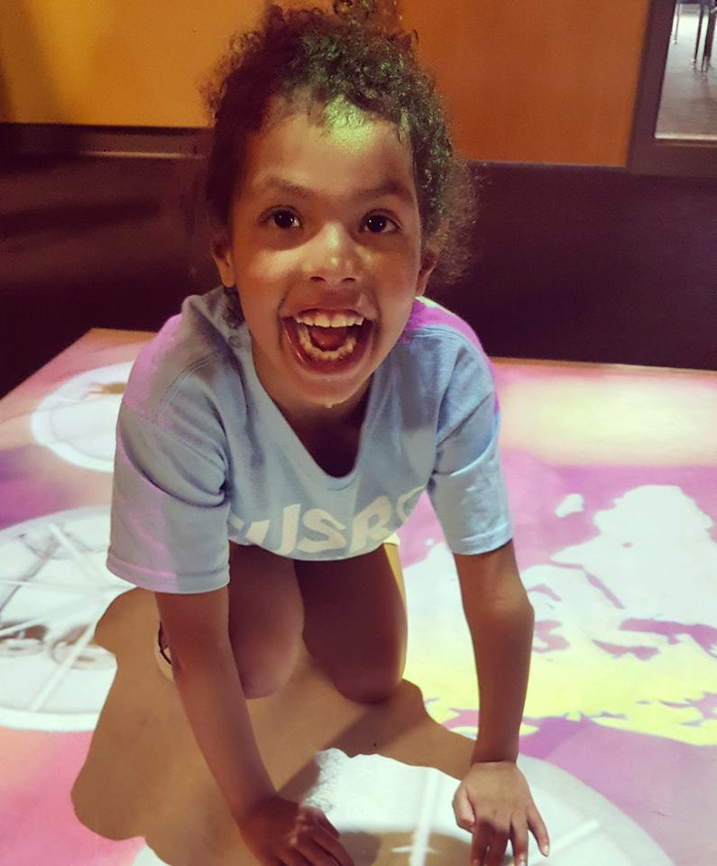





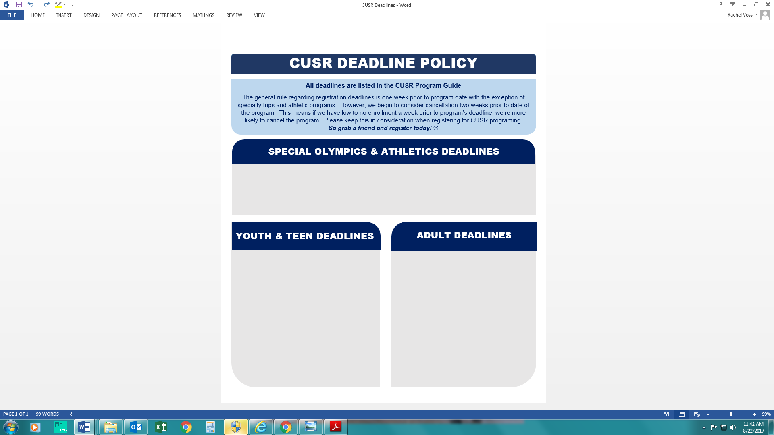

Mustang Aquatics—**January 2nd**

Mustang Power Lifting—**January 8th**

Diner’s Club—**January 18th**

Crafting—**January 16th**

Jumpin’ @ Jupiter’s—**January 22nd**

Dancing in Decatur—**December 27th**

Dinner & Cosmic Bowling—**December 8th**

Karaoke & Dancing—**December 15th**

Movie Critics—**December 29th**

Movie Night—**January 19th**

Elf, the Musical—**December 29th**

Market Place Mall Scavenger Hunt—

**December 2nd**

Professional Bull Riding—**January 5th**

Wine Glasses & Mocktails—**January 4th**

Tie-Dye Party—**January 8th**

Discovering the Eagles**—January 17th**

Chicago Bulls Basketball**—January 19th**

Pizza & Movie**—January 24th**

Theatre 101**—January 9th**

**Martial Arts: 16-35**

December 27th

**After School Program: 5-22**

January—**December 29th**

February—**January 25th**

March—**February 22nd**

April—**March 26th**

May—**April 24th**